Ohmmeter
Definition: The meter which measures the resistance and the continuity of the electrical circuit and their components such type of meter is known as the ohmmeter. It measures the resistance in ohms. The micro-ohmmeter is used for measuring the low resistance and the mega ohmmeter measures the high resistance of the circuit. The ohmmeter is very convenient to use but less accurate.

Types of Ohmmeter
The ohmmeter gives the approximate value of resistance. It is very portable and hence used in the laboratory. It is of three types; they are the series ohmmeter, shunt ohmmeter and multi-range ohmmeter. The detail explanation of their types is given below.

Series Ohmmeter
In series ohmmeter, the measuring resistance component or circuit is connected in series with the meter. The value of resistance is measured through the d’Arsonval movement connected in parallel with the shunt resistor R₂. The parallel resistance R₂ is connected in series with the resistance R₁ and the battery. The component whose resistance is used to be measured is connected in series with the terminal A and B.
The circuit diagram of the series ohmmeter is shown in the figure below.
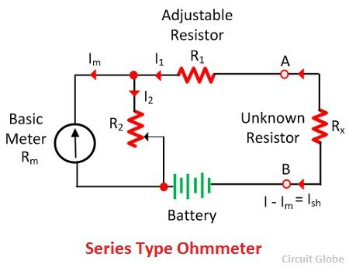
When the value of unknown resistance is zero the large current flow through the meter. In this condition, the shunt resistance is adjusted until the meter indicates the full load current. For full load current, the pointer deflects towards zero 0 ohms.
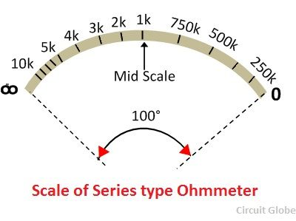
When the unknown resistance R_{x} is removed from the circuit the resistance of the circuit becomes infinite and no current flow through the circuit. The pointer of the meter deflects towards the ∞ (infinity). The meter shows the infinite resistance at zero current and the zero resistance when full range current flows through it.
When the unknown resistance is connected in series with the circuit and if their resistance is high, then the pointer of the meter deflects toward the left. And if the resistance is low, then pointer deflects toward the right.

Shunt Type Ohmmeter
The meter in which the measuring resistance is connected in parallel with the battery is known as the shunt ohmmeter. It is mainly used for measuring the low-value resistance.
The circuit diagram of the shunt ohmmeter is shown in the figure below.
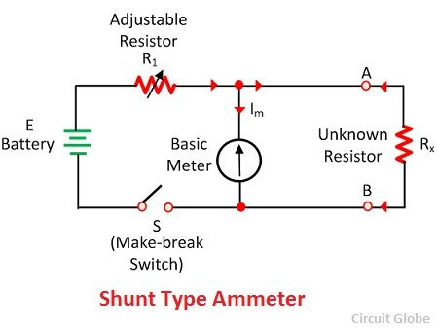
The battery (E), basic meter (R_{m}) and the adjustable resistance are the main components of the shunt ohmmeter. The unknown resistance is connected across terminal A and B.
When the value of unknown resistance is zero the meter current becomes zero. And if the resistance becomes infinite (i.e., the terminal A and B are open) then the current passes through the battery and the pointer shows the full-scale deflection toward left. The shunt type ohmmeter has the zero mark (no current) on the left of the scale and the infinity mark on their right side.
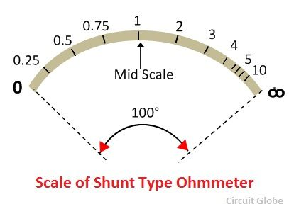

Multi-Range Ohmmeter
The range of this type of ohmmeter is very high. The meter has adjuster which selects the range according to need.
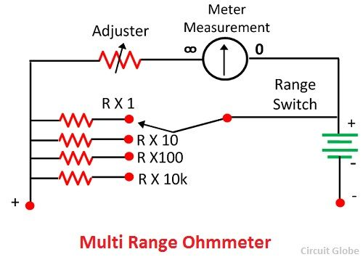
For example, consider we use the meter for measuring the resistance under 10 ohms. For this first, we have to set the range of 10 ohms. The resistance whose value is used to be measured is connected in parallel with the meter. The magnitude of the resistance is determined through the deflection of the pointer.

Electronic Multimeter
Definition: The Electronic Multimeter is a device which is used for the measurement of various electrical and electronic quantities such as current, voltage, resistance etc. The multimeter name is given to it to define its ability to measure multiple quantities.
It is provided with inbuilt power supply necessary for the functioning of the device. Any component such as a resistor, battery can be connected to its outer probes for the measurement of the electronic quantity. In order to understand how a single meter can measure multiple electrical quantities, we need to look into its constructional feature and the components which make it a multimeter.

Construction and Components of Multimeter
The multimeter basically consists of a bridge DC amplifier, rectifier, PMMC meter, function switch, internal battery and an attenuator. The function of the attenuator is that it helps to select a particular range of voltage values. The rectifier is essential in a multimeter for the conversion of AC voltage into DC voltage. The internal battery is needed for the operational mechanism of the multimeter.
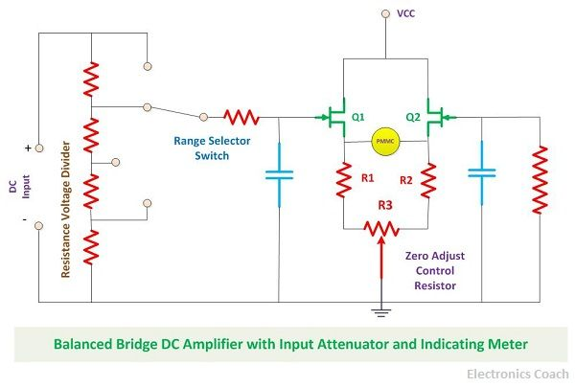
The Bridge DC amplifier is nothing but two Field effect transistor connected opposite to each other with three resistors and forming a bridge-like structure. The two resistors are for balancing the bridge, and the third resistor is a zero adjust control resistor.

Working of the Multimeter
The Multimeter performs its operation by providing the input voltage to the gate terminal of the FET, and this gate voltage is responsible for the increase in the source voltage of the FET. The PMMC meter is connected between the two FET.
In the ideal condition, no current should flow from PMMC meter so thus it must show zero deflection, but in the practical implementation, the PMMC meter shows some deflection. This is undesirable in steady state. Thus a zero adjusts control resistor is used for adjusting the value of current to zero. After this again, the PMMC shows no deflection.
But make sure the above condition is defined when no input is applied to it. When the input is applied to it either by connecting a resistor or any other component, the circuit switched to the active state and the changes in the circuit due to the connection of the component is deflected with the help of PMMC meter.
There are series of steps which is to be followed while measurement. First, the multimeter should be tested whether is it working or not. If it is not working the battery requirements of the device should be checked.
After this, we need to set the knob of the multimeter to set it on the values or quantity which is to be measured. For example, if we want to measure resistance then the multimeter should be set to option “ohm”. Apart from this, we need to set the range of multimeter.
It is significant to set the range of multimeter because if you are measuring the resistance of the resistor which possesses value in kilo-ohms and the range of multimeter is not set and by default it is in ohm or mega-ohms, then you will get wrong results. Therefore it is crucial to set the range of the multimeter properly.

MULTIMETER OR VOLT-OHM-MILLI-AMMETER (V.O.M.)

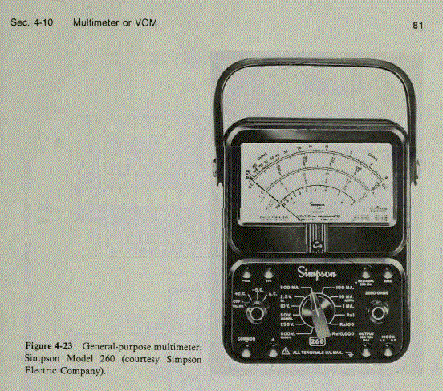

The ammeter, the voltmeter and the ohmmeter all use a basic d'Arsonval movement. The difference between these instruments is the circuit in which the basic movement is used. It is therefore obvious that an instrument can be designed to perform these three measurement functions. This instrument which contains a function switch to connect the appropriate circuits to the d'Arsonval movement, is called a "Multimeter'' or "Volt-ohm-milli-ammeter'' (V.O.M.).

A representative example of a commercial multimeter is the Simpson model 260 whose complete circuit diagram is shown in Fig. 9.16. The meter is a combination of a d.c. milli-ammeter, a d.c. voltmeter, an a.c. voltmeter, a multirange ohmmeter and an output meter.

This multimeter uses a d'Arsonval movement that has a resistance of 2000 Ω and a full scale current of 50 Ω.
The instrument is provided with a selector switch which can be set for different modes of operation like measurement of voltage, current, resistance etc., and also for various ranges of these quantities.
The circuit for d.c. voltmeter section is shown in Fig. 9.17 when common input terminals are used for voltage ranges of 0-1.5 V to 0-1000 V. The range can be set with the help of a selector switch. An external voltage jack marked "DC 5000 V" is used for d.c. voltage measurements upto 5000 V. The values of multiplier resistances are given in the diagram. For use on 5000 V range the selector switch should be set to 1000 V position but the test lead should be connected to the external jack marked "5000 V ", The instrument has a sensitivity of 20 kΩ /V which is fairly high and therefore the instrument is well suited to general service work in electronic measurements.
The circuit for measuring d.c. milliampere and ampere is shown in Fig. 918. The common (+) terminal and negative (-) terminals are used for current measurements upto 500 mA. The jacks marked + 10 A and -10 A are used for 0 - 10 A range.

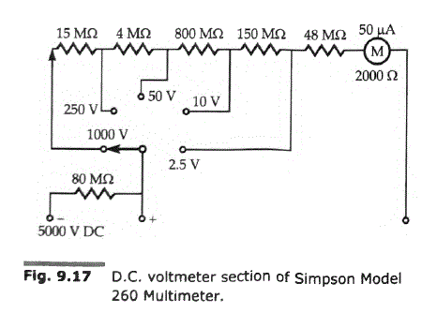
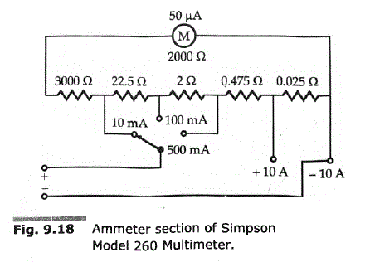

Differential Voltmeter
Definition: The voltmeter which measures the difference between the known and the unknown voltage source is known as the differential voltmeter. It works on the principle of comparison between the reference and the unknown voltage sources.
The accuracy of the differential voltmeter is very high.The principle of operation of the differential voltmeter is similar to that of the potentiometer, and hence it is called potentiometer voltmeter.

Construction of Differential Voltmeter
The circuit diagram of the differential voltmeter is shown in the figure below. The null meter is placed between the unknown voltage source and the precision divider. The output of the precision divider is connected to the known voltage source. The precision divider is adjusted until the meter shows the zero deflection.
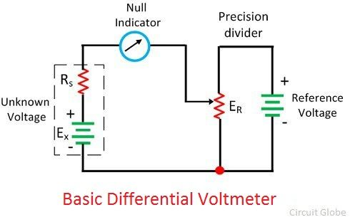
The null deflection of the meter shows that the magnitude of both the known and the unknown voltage source becomes equal. During the null deflection, neither the known nor the unknown source applies current to the meter. And the voltmeter shows the high impedance to the measurand source.
The null meter only shows the residual difference between the known and the unknown voltage source. For determining the exact difference between the sources, the more sensitive meter is used.
The low voltage DC standard source or the low voltage Zener controlled precision supply is used as a reference voltage. The high voltage supply is used for measuring the high voltages.

DIFFERENTIAL VOLTMETERS
6-6.1 Basic Differential Measurement

One of the most accurate methods of measuring an unknown voltage is the differential voltmeter technique, where the voltmeter is used to indicate the difference between the unknown voltage and a known voltage. The principle of operation of the differential voltmeter is similar to that of the potentiometer discussed in Chapter 5 and, for this reason, the instrument is sometimes called a potentiometric voltmeter.

The classic differential voltage measurement is shown in basic form in the circuit of Fig. 6-14. In this circuit, the null meter is connected between the unknown voltage source and the output terminals of a precision voltage divider, and hence indicates the difference between the two. This voltage divider is connected across a reference voltage source and can be adjusted to provide accurately known fractions of the reference voltage.

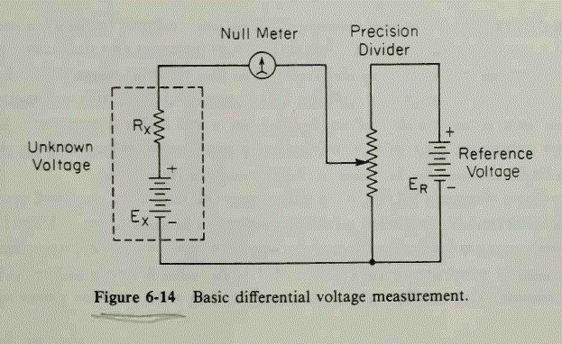

In performing a measurement, the divider is adjusted until its output voltage equals the unknown voltage. The null meter, which is connected between the unknown source and the divider-output terminals, indicates zero volts when the two voltages are equal. In this null condition neither the source nor the reference supplies current to the meter, and the differential voltmeter therefore presents an infinite impedance to the source under test. Note that the null meter serves to indicate only the residual differential between the known voltage and the unknown voltage. To detect small differences in unbalance potentials, a sensitive meter movement is required; accuracy of the meter is of secondary importance since the meter is not used to indicate the absolute value of the unknown voltage.

The reference source usually consists of a low-voltage dc standard, such as a 1-V dc laboratory reference standard or a low-voltage Zener-controlled precision supply.

When measuring high voltages, a high-voltage reference supply can be used. In the usual case, however, a voltage divider is placed across the unknown source to reduce the voltage to a sufficiently low value for direct comparison against the usual low-voltage dc standard. The main drawback of this system is that a differential voltmeter with input divider has a relatively low input resistance, especially for unknown voltages much higher than the reference standard. This low input resistance is undesirable because of its loading effect. A differential voltmeter offers an input resistance approaching infinity only at the null condition and then only if an input divider is not used.

The ac differential voltmeter is a modification of the dc instrument and incorporates a precision rectifier circuit. The unknown ac voltage is applied to the rectifier for conversion to a dc voltage equivalent to the average value of the ac. The resulting dc is then applied to the potentiometric voltmeter in the usual manner. The simplified block diagram of an ac differential voltmeter shown in Fig. 6-15 is self-explanatory.

True RMS Voltmeter:
True RMS Voltmeter – Complex waveform are most accurately measured with an rms voltmeter. This instrument produces a meter indication by sensing waveform heating power, which is proportional to the square of the rms value of the voltage. This heating power can be measured by amplifying and feeding it to a thermocouple, whose output voltages is then proportional to the E_{rms}.
However, thermocouples are non-linear devices. This difficulty can be overcome in some instruments by placing two thermocouples in the same thermal environment.
Figure 4.25 shows a block diagram of a true rms responding voltmeter.
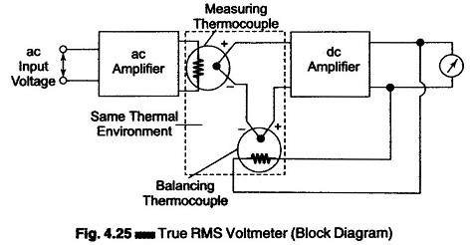
The effect of non-linear behavior of the thermocouple in the input circuit (measuring thermocouple) is cancelled by similar non-linear effects of the thermocouple in the feedback circuit (balancing thermocouple). The two couples form part of a bridge in the input circuit of a dc amplifier.
The unknown ac voltage is amplified and applied to the heating element of the measuring thermocouple. The application of heat produces an output voltage that upsets the balance of the bridge.
The dc amplifier amplifies the unbalanced voltage; this voltage is fed back to the heating element of the balancing thermocouple, which heats the thermocouple, so that the bridge is balanced again, i.e. the outputs of both the thermocouples are the same. At this instant, the ac current in the input thermocouple is equal to the dc current in the heating element of the feedback thermocouple. This dc current is therefore directly proportional to the effective or rms value of the input voltage, and is indicated by the meter in the output circuit of the dc amplifier. If the peak amplitude of the ac signal does not exceed the dynamic range of the ac amplifier, the true rms value of the ac signal can be measured independently.
6-3 TRUE RMS-RESPONDING VOLTMETER

Complex waveforms are most accurately measured with an rms-responding voltmeter. This instrument produces a meter indication by sensing waveform heating power, which is proportional to the square of the rms value of the voltage. This heating power can be measured by feeding an amplified version of the input waveform to the heater element of a thermocouple whose output voltage is then proportional to E²_{rms}.
One difficulty with this technique is that the thermocouple is often nonlinear in its behavior. This difficulty is overcome in some instruments by placing two thermocouples in the same thermal environment, as shown in the block diagram of the true rms-responding voltmeter of Fig. 6-8. The effect of the nonlinear behavior of the couple in the input circuit (the measuring thermocouple) is canceled by similar nonlinear effects of the couple in the feedback circuit (the balancing thermocouple). The two couple elements form part of a bridge in the input circuit of a dc amplifier. The unknown ac input voltage is amplified and applied to the heating element of the measuring thermocouple.
The application of heat produces an output voltage that upsets the balance of the bridge. The unbalance voltage is amplified by the dc amplifier and fed back to the heating element of the balancing thermocouple. Bridge balance will be reestablished when the feedback current delivers sufficient heat to the balancing thermocouple, so that the voltage outputs of both couples are the same. At this point the dc current in the heating element of the feedback couple is equal to the ac current in the input couple. This dc current is therefore directly proportional to the effective, or rms, value of the input voltage and is indicated on the meter movement in the output circuit of the dc amplifier. The true rms value is measured independently of the waveform of the ac signal, provided that the peak excursions of the waveform do not exceed the dynamic range of the ac amplifier.
A typical laboratory-type rms-responding voltmeter provides accurate rms readings of complex waveforms having a crest factor (ratio of peak value to rms value) of 10/1. At 10 per cent of full-scale meter deflection, where there is less chance of amplifier saturation, waveforms with crest factors as high as 100/1 could be accommodated. Voltages throughout a range of 100 ftV to 300 V within a frequency range of 10 Hz to 10 MHz may be measured with most good instruments.

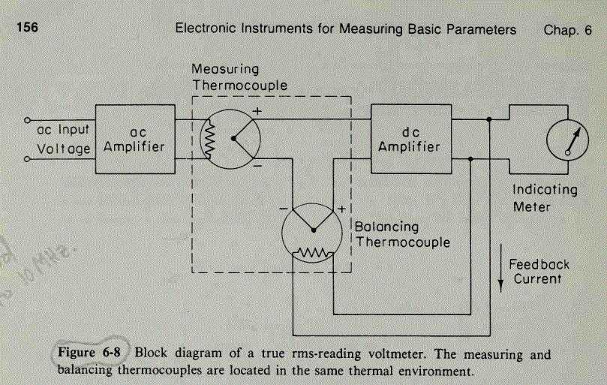

AC voltmeter and multirange voltmeter

The instrument, which is used to measure the AC voltage across any two points of electric circuit is called AC voltmeter. If the AC voltmeter consists of rectifier, then it is said to be rectifier based AC voltmeter.
The DC voltmeter measures only DC voltages. If we want to use it for measuring AC voltages, then we have to follow these two steps.
- Step1 − Convert the AC voltage signal into a DC voltage signal by using a rectifier.
- Step2 − Measure the DC or average value of the rectifier’s output signal.
We get Rectifier based AC voltmeter, just by including the rectifier circuit to the basic DC voltmeter. This chapter deals about rectifier based AC voltmeters.

AC Voltmeter using Full Wave Rectifier
If a Full wave rectifier is connected ahead of DC voltmeter, then that entire combination together is called AC voltmeter using Full wave rectifier. The block diagram of AC voltmeter using Full wave rectifier is shown in below figure
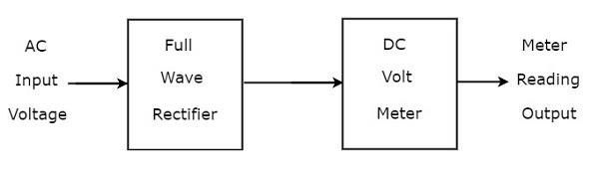
The above block diagram consists of two blocks: full wave rectifier and DC voltmeter. We will get the corresponding circuit diagram just by replacing each block with the respective component(s) in above block diagram.
So, the circuit diagram of AC voltmeter using Full wave rectifier will look like as shown in below figure.
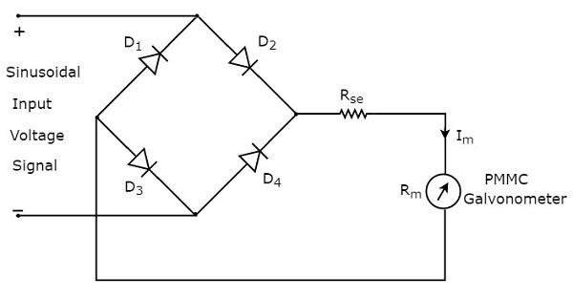

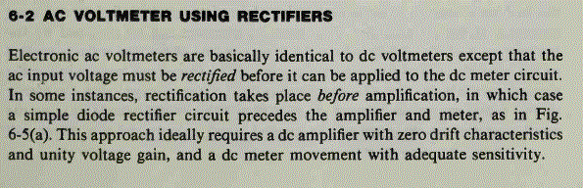
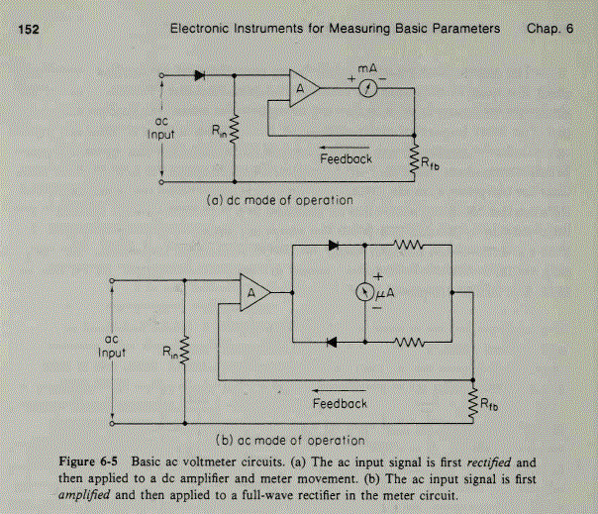
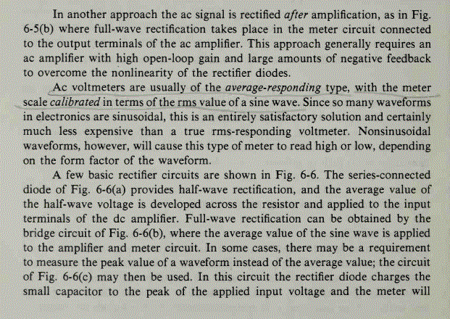
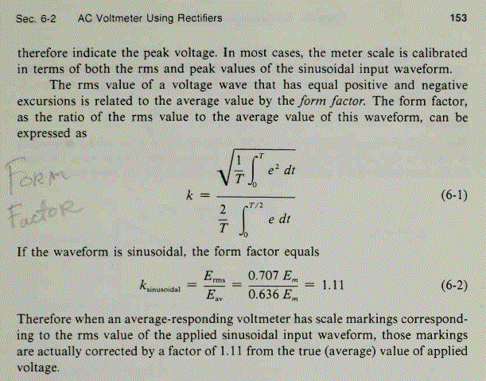
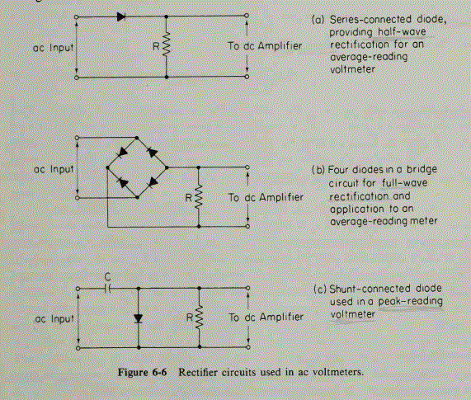

  - Review of DC/AC voltmeter and Ammeter : The D'Arsonval Principle

2.1. INTRODUCTION

A variety of instruments are available for the measurement of the different electrical variables. The used principles include the electromechanical meter movement, electromagnetic induction, thermocouples, and electronic meters.

The permanent magnet moving coil instruments are based on the galvanometer invented by Arsene d’Arsonval. This device possesses a stationary permanent magnet, a moving coil, a spring, and a pointer attached to the coil. Figure 2.1 illustrates the way the equipment works. When a current flows through the coil, there is an induced force on it due to the created electromagnetic field, and the coil rotates around its central axis until the induced torque is equal and opposite to the spring torque. The rotation torque, and consequently the angle the pointer rotates is proportional to the current. The rotation angle is measured on a calibrated scale, and the amount of current flowing through the meter can be measured. The d’Arsonval movement is used basically to measure average or DC currents and voltages.

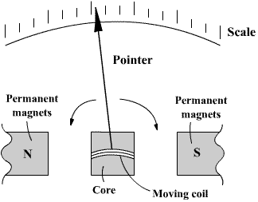

Figure 2.1. d’Arsonval Meter Movement

2.2. –VOLTAGE, CURRENT, AND RESISTANCE MEASUREMENTS

Figure 2.2 shows a device based on the d’Arsonval movement, which is frequently used for measuring different electrical quantities. This equipment is known as analogical multimeter. By locating the range switch and the function switch in the proper position, the desired variable may be measured in the selected scale.

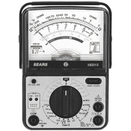

Figure 2.2. Analog Multimeter

Current Measurement

This type of device is used to measure currents typically up to 1 Amp.
1) The first step is to locate the range and function switches in the proper position, observing that the function switch is in the AC or DC current position, and the range switch actually selecting a range with maximum value higher than the expected current value.
2) The meter is connected, using its leads, in series with the element where the current is going to be measured, as can be seen in figure 2.3.

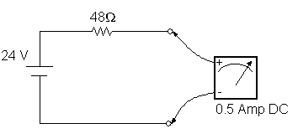
Figure 2.3. Current Measurement

Voltage Measurement

1) Select the AC or DC voltage position, depending on the characteristics of the measured voltage, and select also the correct scale.
2) Connect the meter in the way shown in Figure 2.4.

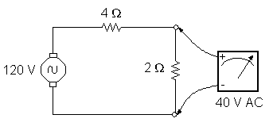 Figure 2.4. Voltage Measurement

Resistance Measurement

1) Select the resistance (Ohm) position
2) Connect the meter leads to the terminals of the measured device.

It is important to be aware of the fact that the device resistance shall never be measured if it is connected to the energy source or to other devices. For measuring the resistance, the device will be isolated from the rest of the circuit.

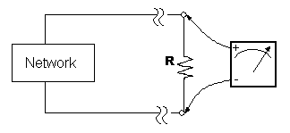

Figure 2.5 Resistance Measurement

